Example: alignment of LeuT and BetP transporters.

Membrane proteins are often difficult to align as they may have hardly any similarity in sequence even when structurally and functionally related

Fig. 1 outlines the workflow of using anchors for the alignment of very distantly related sequences. For both query sequences, homologous sequences were collected using PSI-BLAST and a multiple sequence alignment is created using MUSCLE for both individually. The two MSAs are used as input for the AlignMe server profile-profile mode using default values. The server creates an averaged hydropathy profile for each of the MSAs and aligns them (Fig. 2). Afterwards, the averaged profile is mapped back on the initial query sequences (Fig. 3).

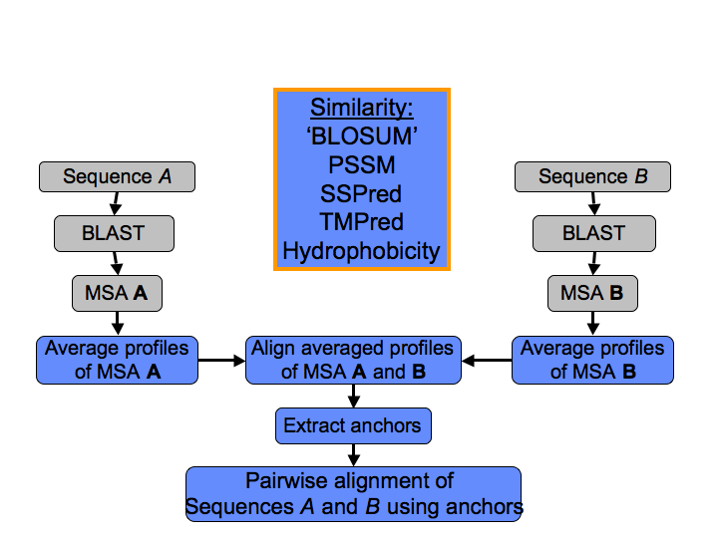

Figure 1: The workflow of the alignment strategy for proteins sharing hardly any similarity on a sequence level. (In blue are the steps using AlignMe.)

Beside being both sodium symporter proteins, BetP and LeuT also share the inverted 5TM repeat topology. In the HOMEP2012 database they were identified as belonging to the same structural family of proteins. They constitute an excellent example of two trans-membrane proteins belonging to the same structural and functional family while hardly sharing any similarity at the sequence level. While they share the same topology, terminal helices are shifted relative to the repeats, posing an additional challenge to the alignments. LeuT has 2 helices after the repeats, while BetP has them before the repeats.
The first step is to create a MSA using MUSCLE for each query sequence and to align the resulting pair of MSAs using AlignMe<>MSA. This returns an aligned hydropathy profile, mapped back on the query sequences, shown in Fig. 2. The resulting alignment reflects well the expected structural features explained in the previous section. Here, we noticed a significant difference between MUSCLE and T-Coffee. Using latter was not resulting in an alignment reflecting the structural relationship.

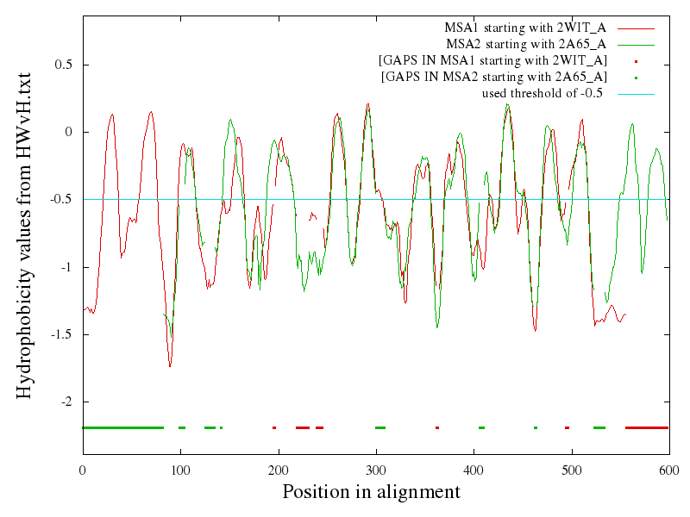
Figure 2: AlignMe<>MSA’s aligned profiles of the MSAs of 2WIT (BetP) and 2A65 (LeuT). From this alignment achors were derived.

From this alignment we selected the anchors as the identical matches. This somewhat arbitrary choice was driven by the intention to guide the alignment, while leaving some flexibility for the alignment algorithm to find the best solution. Fig. 3 shows the aligned MSAs and Fig. 4 the anchors that were selected. Identical positions selected as anchors are the ones denoted by ‘*’ in Fig. 3. Note that these are sequence positions (starting from zero), not positions from Fig. 2.

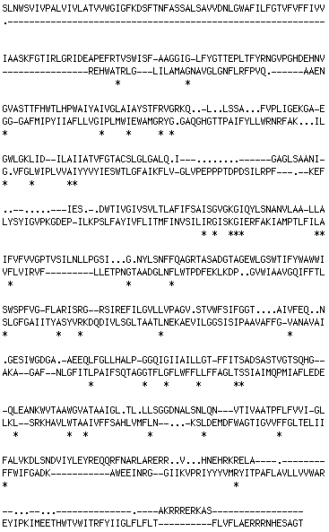

Figure 3: AlignMe’s aligned MSAs of 2WIT (BetP) and 2A65 (LeuT) mapped back onto the query sequences.

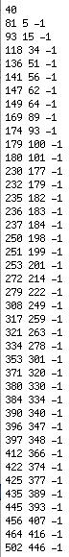

Figure 4: the selected anchors in the format they need to be provided. Each line represents one anchor. The first number indicates the residue ID in the first sequence, the second the according in the second sequence, the third number is the weight of the anchor.

Having the anchors selected from the aligned MSAs, the last step is to create a pairwise alignment of the query sequences. Fig. 5 shows a comparison of the resulting anchored pairwise alignment with the structural alignment created using SKA.

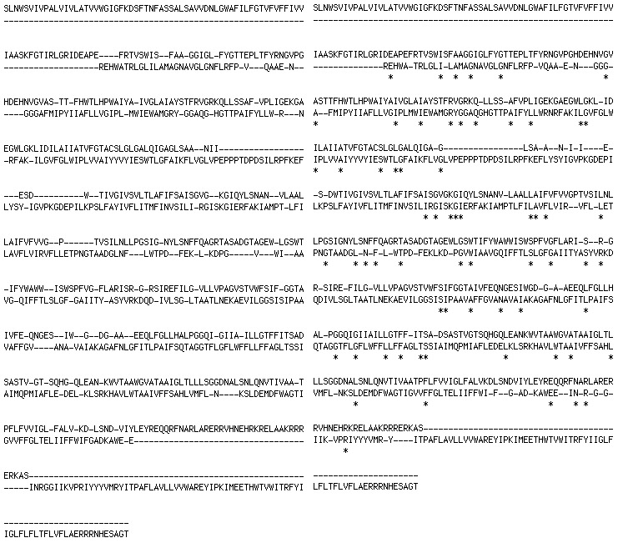

Figure 5: Left: Ska structural alignment. Right: anchored alignment.

Below, in Fig. 6, you will find two example profiles, aligned using the anchors. The one for transmembrane prediction, and the one with helix prediction. For comparison Fig. 7 shows the same profiles created without anchors. Fig. 8 shows the comparison of aligned sequences with and without anchors. The alignments differ significantly and seem greatly improved due to the anchors. This reflects the expected fact that for these highly challenging cases a basic pairwise alignment will not suffice to get a proper alignment. The improvement due to the usage of anchors becomes most obvious when looking at the alignment of the profiles.

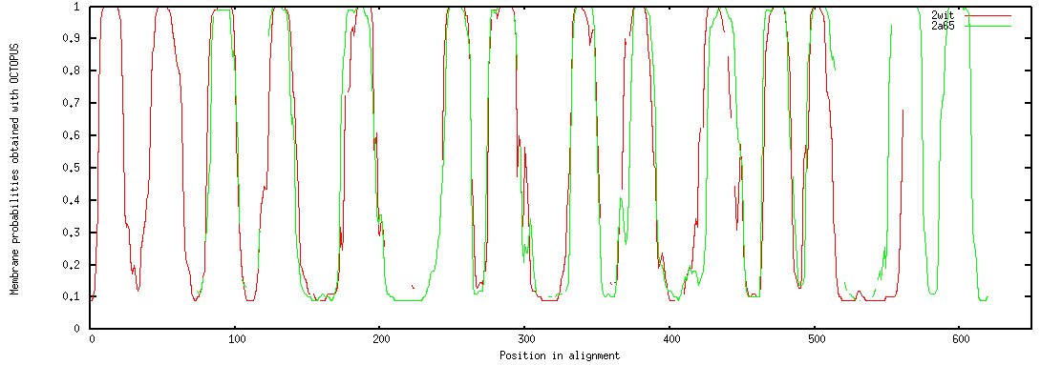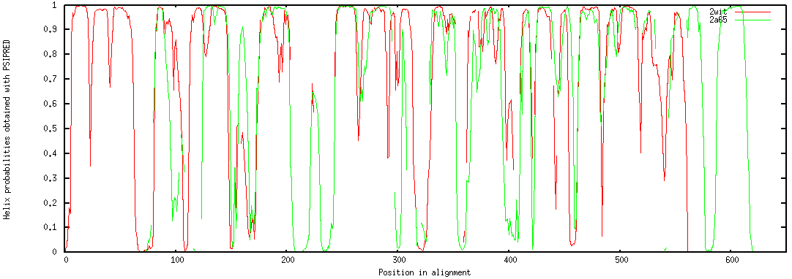

Fig 6: Pairwise alignment of BetP (red) and LeuT (green) using anchors. Alignment settings are the AlignMe PST for distantly related sequences using PSIPRED, its PSSM, and Octopus. Top: alignment of Octopus transmembrane prediction. Bottom: alignment of PSIPRED helix secondary structure predictions.

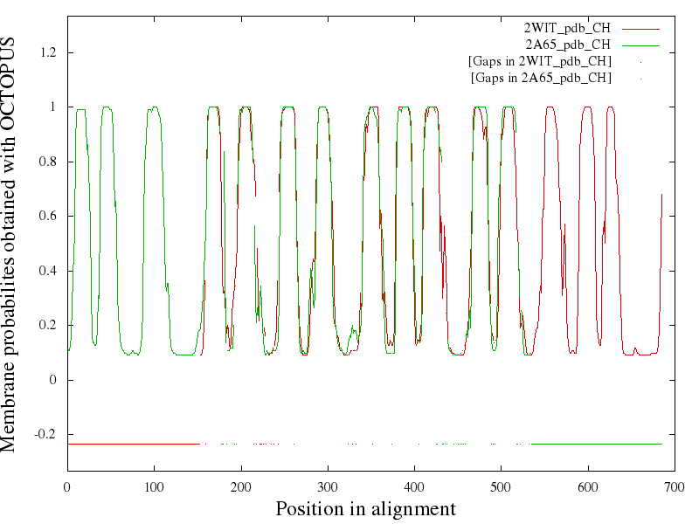
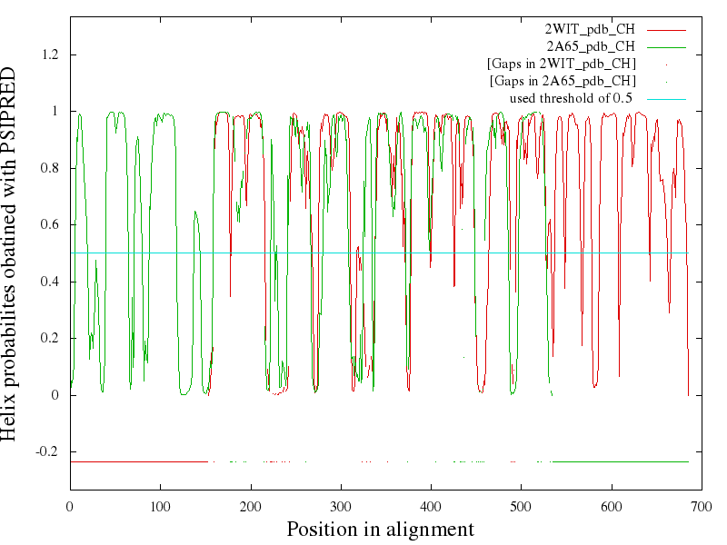

Fig 7: Аlignment of BetP (red) and LeuT (green) profiles without anchors. Alignment settings are the AlignMe PST for distantly related sequences using PSIPRED, its PSSM, and Octopus.Top: transmembrane predictions, bottom: helix secondary structure prediction.
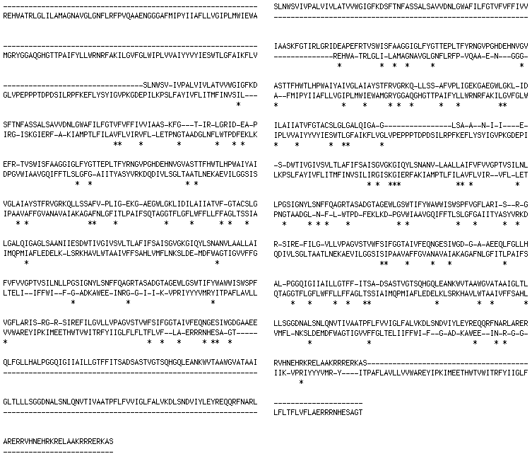

Fig 8: Pairwise alignment of BetP (top sequence) with LeuT (lower sequence). Left: basic pairwise alignment without anchors. Right: with anchors.

